Parallel and Distributed Computing

1. Definition
Parallel Computing:
Parallel computing is a type of computation where many calculations or processes are carried out simultaneously. Tasks are divided into smaller sub-tasks and executed concurrently using multiple processors or cores within a single machine to reduce execution time.
Distributed Computing:
Distributed computing is a model in which computational tasks are divided across multiple interconnected computers (nodes) that communicate and coordinate with each other via a network. Each node works independently on a portion of the problem, and results are combined to solve the overall problem.
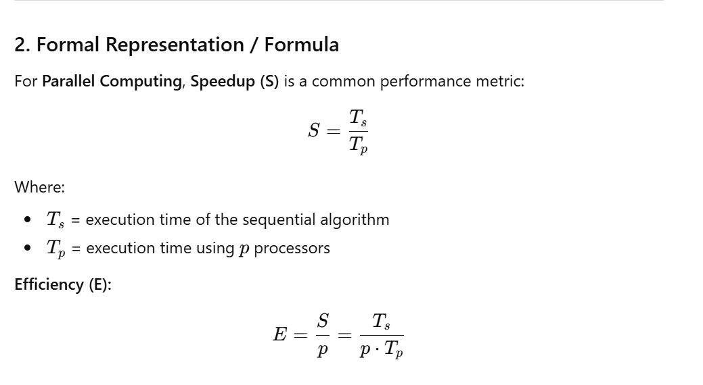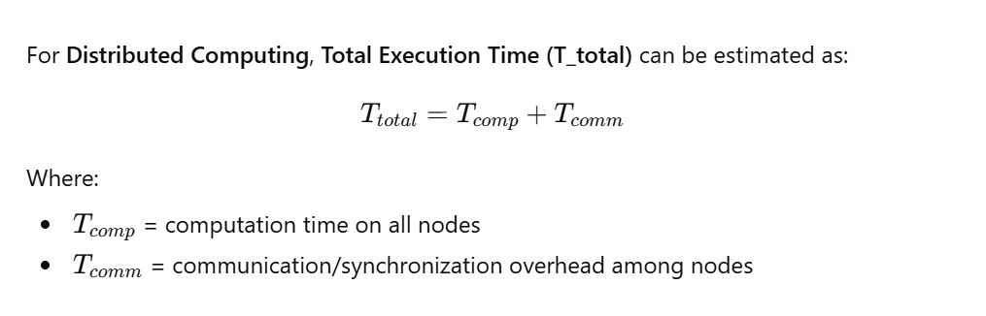
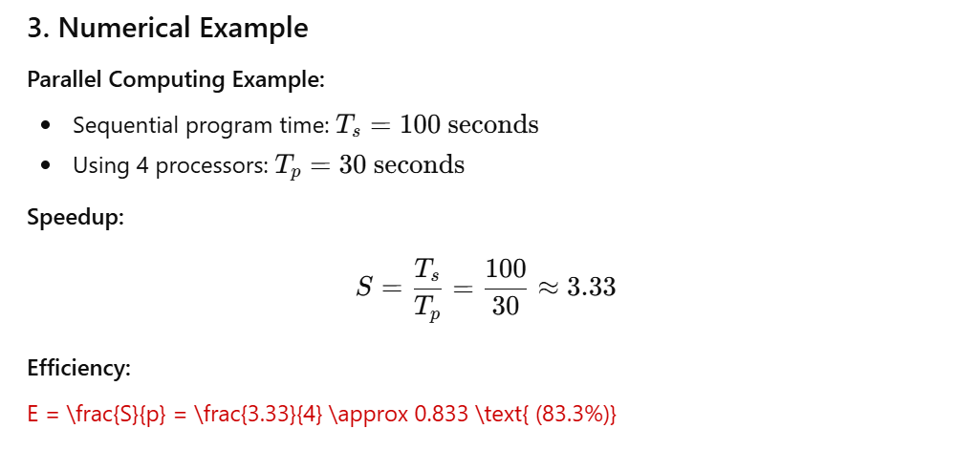
https://chatgpt.com/share/6976197a-2ef4-8001-900c-24c6f02a5e45

